# **Chapter** **4 Requirement Collection and Analysis**

This chapter provides an overview of the data and requirement collection and analysis processes conducted for the development of an online marketplace system. To gather the necessary data, an online survey was conducted, enabling us to gain insight into the opinions and perspectives of potential users regarding the concept of an online marketplace system. Additionally, this chapter outlines the functional and non-functional requirements identified for the system. Furthermore, the system models of our system, which is the traditional approach, are presented in this chapter, as well as personas.

## **Requirement Elicitation**

-

dec

-

### **Survey Questions and Analysis**

The survey was distributed to multiple social media groups, resulting in a total of 57

responses.

### **Regarding question 1, “Your age”,**

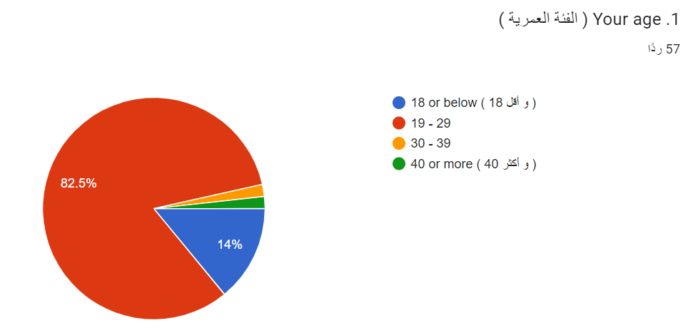

*Figure 4.1: Age participants*

The age groups of the participants can be observed in Figure 4.1, displayed above. A large portion of the survey participants, who constitute (82.5%) of the total survey participants, belong to the age group of 19–29 years. This indicates that the survey targeted the youth group. The percentage of participants aged 18 years or younger represented (14%) of the total responses. On the other hand, the age groups 30–40 and over were the least active in terms of respondents, with a rate of (1.75%).

### **Regarding question 2, “Your Gender”,**

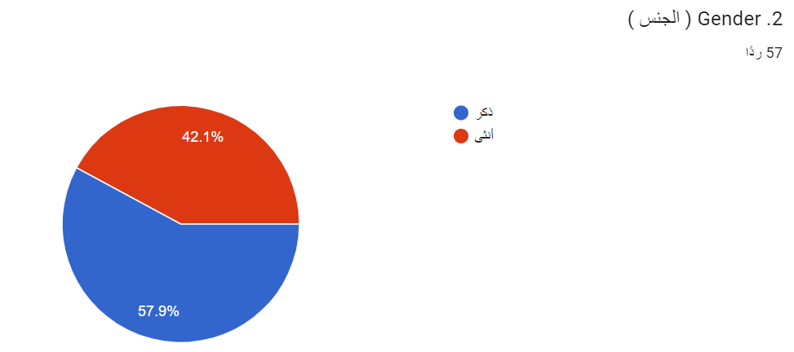

*Figure 4.2: Gender participants*

The gender of the participants can be observed in Figure 4.2, displayed above. The majority of individuals participating in the survey, (57.9%), are male, while females constitute (42.1%) of the respondents.

### **Regarding question 3, “Your Qualification”,**

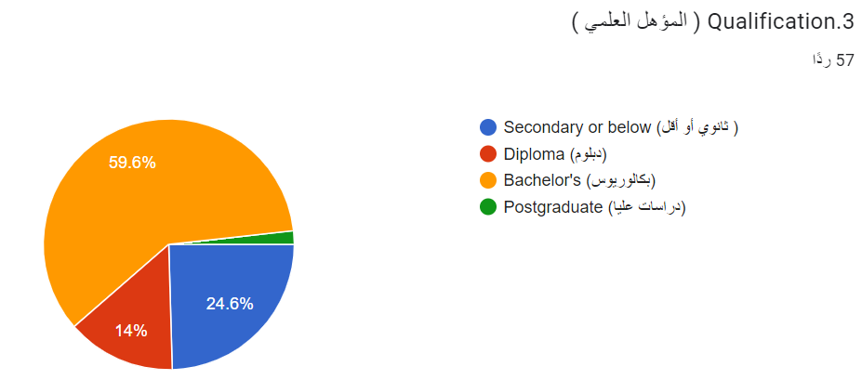

*Figure 4.3: Qualification participants*

The qualifications of the participants can be observed in Figure 4.3, displayed above. The results show that the majority of people who participated in the survey had completed a bachelor’s degree making up (59.6%) of the participants. This indicates that the survey primarily attracted participants with undergraduate qualifications. Around (24.6%) of respondents had education or lower qualifications suggesting that there were a few participants with less formal education in the sample. A smaller percentage, (14%) held a diploma. Those with postgraduate qualifications were less represented, comprising 1.8% of the respondents.

### **Regarding question 4, “Have you been having difficulty selling electronic items”,**

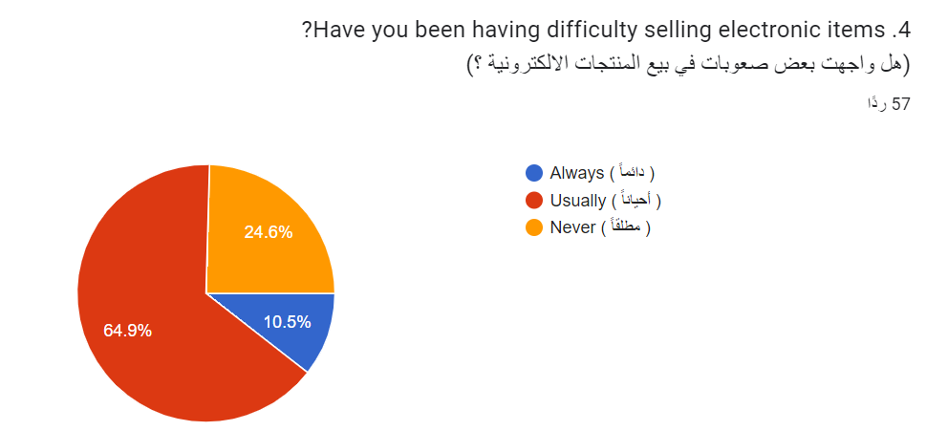

*Figure 4.4:* *Distribution of responses to the question, "Have you been having difficulty selling electronic items?”*

The distribution of responses to the question above can be observed in Figure 4.4, displayed above. Based on the survey responses most of the participants (64.9%) mentioned that they have faced difficulties when selling items. This indicates that a considerable number of respondents have encountered challenges in the process of selling products. On the side a smaller percentage of participants (10.5%) stated that they consistently face difficulties in selling items. These individuals consistently find it challenging to sell products. In contrast a minority of respondents (24.6%) mentioned that they never face any obstacles when it comes to selling items. These individuals have not encountered any hindrances or challenges in their electronic product sales. These findings highlight the fact that selling items can be quite demanding for a portion of the participants.

### **Regarding question 5, “Do you usually have electronic items at home that you want to sell”,**

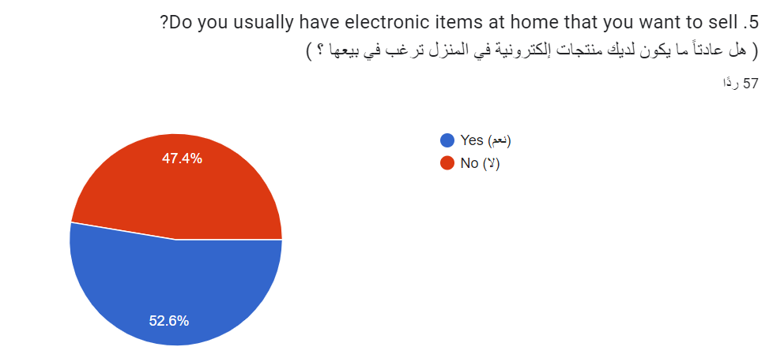

*Figure 4.5: Distribution of responses to the question, " Do you usually have electronic items at home that you want to sell?”*

The distribution of responses to the question above can be observed in Figure 4.5, displayed above. Based on the survey findings the majority of participants (52.6%) mentioned that they typically have items at home that they would like to sell. This shows that a significant number of respondents have products they are interested in putting up for sale. On the other side a considerable proportion of participants (47.4%) stated that they do not usually have items at home that they want to sell. This implies that many participants don't have items with the intention to sell them. However, this percentage is still lower than those who do have items they wish to sell. These results highlight the fact that a significant portion of survey participants own items at home to be sold.

### **Regarding question 6, “Do you think having an online marketplace system will help you sell your electronic items faster”,**

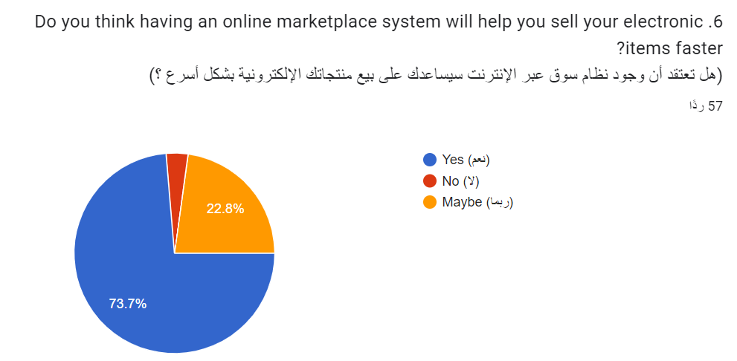

*Figure 4.6: Distribution of responses to the question,*

*“Do you think having an online marketplace system will help you sell your electronic items faster?”*

The distribution of responses to the question above can be observed in Figure 4.6, displayed above. Based on the survey findings a considerable number of respondents (73.7%) believe that utilizing a market platform can expedite the sale of their goods. A small percentage of participants (3.5%) hold a perspective expressing doubts, about the effectiveness of a marketplace in facilitating faster sales for their electronic items. Additionally (22.8%) provided a response stating uncertainty about whether or not an online market system would contribute to selling their products more quickly.

The objective behind this question was to assess the benefits of employing a marketplace for users aiming to sell their items faster. The results suggest that implementing such a platform could indeed offer a solution for individuals seeking means to sell their electronic products.

### **Regarding question 7, “Would you like to have an online marketplace to sell/buy electronic items”,**

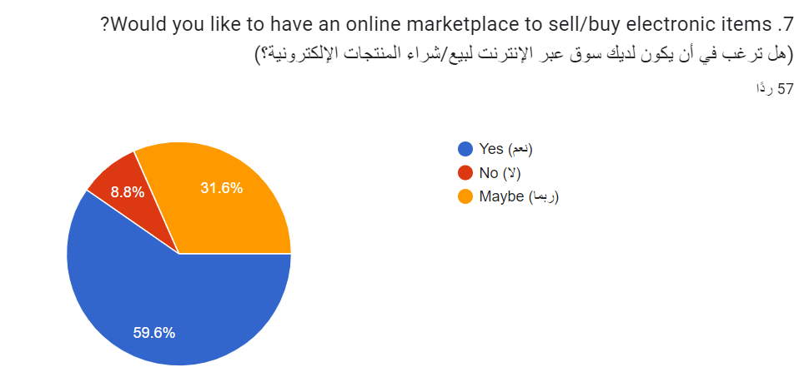  
 *Figure 4.7: Distribution of responses to the question,*

*“Would you like to have an online marketplace to sell/buy electronic items?”*

The distribution of responses to the question above can be observed in Figure 4.7, displayed above. The survey result shows that a percentage (59.6%) of participants said that it would be beneficial to have an online market to buy or sell electronic items. While a notable portion of participants (31.6%) responded “maybe,” And a small percentage of participants (8.8%) indicated a lack of interest in having an online market for electronic goods. This suggests that a minority of participants do not realize the need or advantages of using such a platform.

### **Regarding question 8, “Do you prefer to sell your electronic items online or in traditional way”,**

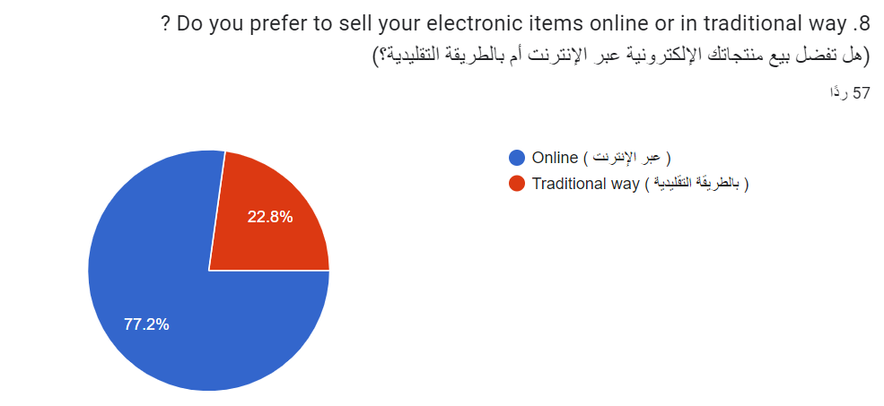

*Figure 4.8: Distribution of responses to the question,*

“Do you prefer to sell your electronic items online or in traditional way?”

The distribution of responses to the question above can be observed in Figure 4.8, displayed above. The survey result shows that a percentage (77.2%) of participants prefer to sell their electronic items online. While a small percentage of participants (22.8%) prefer the traditional way.

### **Regarding question 9, “Having an online marketplace system would benefit both Shop owners and people who want to sell their electronic items”,**

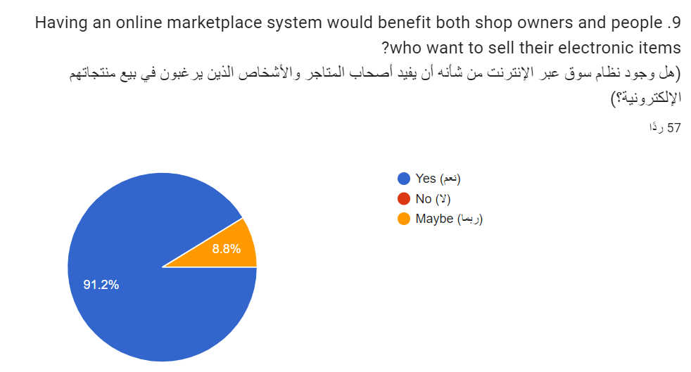

*Figure 4.9: Distribution of responses to the question,*

*“Having an online marketplace system would benefit both Shop owners and people who want to sell their electronic items?”*

The distribution of responses to the question above can be observed in Figure 4.9, displayed above. The survey results indicate that a significant majority of respondents (91.2%) believe that an online marketplace system would be advantageous for both store owners and individuals selling electronic goods. A minority of participants (8.8%) expressed a contrasting viewpoint, suggesting skepticism regarding the benefits of an online trading system for both store owners and individuals selling electronic items.

These findings reveal the overall positive perceptions of participants regarding the potential advantages of an online marketplace system.

### **Regarding question 10, “It will be easier to gain customer if the interface is user-friendly satisfaction”,**

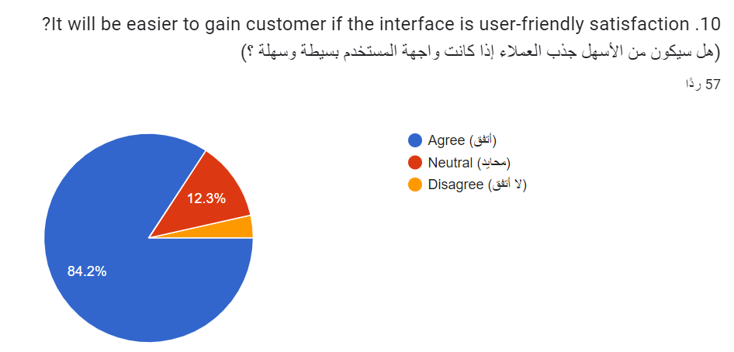

*Figure 4.10: Distribution of responses to the question,*

*“It will be easier to gain customer if the interface is user-friendly satisfaction?”*

The distribution of responses to the question above can be observed in Figure 4.10, displayed above. The survey result shows that a large percentage (84.2%) of participants believe that it will be easier to gain customers if the interface is user-friendly. While a smaller proportion of participants (12.2%) expressed a neutral stance, in addition, an unnoticeable percentage of participants disagreed on that.

## **System Requirements**

System needs are the crucial components that must be present for the system to function properly and as designed. Poor requirement implementation will result in the system performing below expectations and having some issues.

### **Functional Requirements**

The tasks that users should be able to complete on a system are defined by the functional requirements, as well as the system itself. Gaining a general understanding of the system's functioning is beneficial.

**User:**

1. The user must be able to login to the website.
2. The user must be able to logout of the website.
3. The user can create an account on the website.
4. The user can edit his/her account.
5. The user can add a post to the website.
6. The user can delete a post on the website.
7. The user can edit the post details on the website.
8. Users should be able to communicate with sellers via text chat in real time.
9. The user can view seller posts.
10. The user can delete his or her account.
11. The user can view other users' profiles.
12. The user can sort ads by price.
13. The user can search for ads by seller location.
14. The user can search for ads by category.
15. The user can search for ads by sub-category.
16. The user can open a shop on the website.
17. The user can edit the shop page on the website.
18. The user can delete his or her shop from the website.
19. The website allows buyers to rate shops.
20. The seller's location can be viewed by the buyer.
21. The user can add a list of his favorite posts.
22. The user can submit Contact Us form to enable communication with the user.
23. The user must be able to login to the website
24. The user must be able to logout of the website
25. The user can create an account on the website.
26. The user can edit his/her account

**Moderator:**

1. The moderators can delete a post.
2. The moderators can accept post requests.
3. The moderators can reject the post requests.
4. The moderators can delete comments.
5. The moderators can delete users.
6. The moderators can delete shop.
7. Moderators should have the ability to review and moderate user-generated content.
8. Moderator should be responsible for responding to the user's Contact Us form.
9. The moderator should have the capability to access all the users of the website.
10. The moderator should have the capability to access all the advertisements that are on the website.
11. The moderator should have the capability to access all the available shops on the website.
12. The moderator must be able to login.
13. The moderator must be able to logout.
14. The moderator can edit his/her account
15. The moderator must be able to add category
16. The moderator must be able to add sub- category
17. The moderator must be able to edit category
18. The moderator must be able to edit sub- category

**Admin:**

1. The admin can assign new moderators.
2. The admin can delete moderators.
3. The admin can block users.
4. The admin can delete shop.
5. The admin can send messages for the users
6. The admin must have full access to the database and system.
7. The admin can delete a post.
8. The admin can generate reports about users.
9. The admin can generate reports about ads.
10. The admin can generate reports about shops.
11. The admin can generate reports about contact forms.
12. The admin can generate reports about categories.
13. The admin can edit his/her account.
14. The admin must be able to login.
15. The admin must be able to logout.
16. The admin must be able to add category
17. The admin must be able to add sub-category
18. The admin must be able to edit category
19. The admin must be able to edit sub-category

### **Non-Functional Requirements**

A system's quality can be improved by using a set of non-functional requirements.

|  |  |
| --- | --- |
| Security | By using encrypted and secure  databases, the system should offer users high levels of security for their personal information. |
| Usability | The user should be able to navigate throw the system easily and without any trouble or complexity.  The user should be able to get what he intended using a few clicks.  The system design should be simple and pleasant to use. |
| Reliability | The system failure should not exceed 5 percent of use cases during a month. |
| Availability | The system should be available for the user the whole time. |
| Maintainability | The system failure should be restored within 20 minutes. |

## **Personas**

Personas are fictional characters for the users of the system, which include the user, moderator, and admin. An online tool has been used to create these characters

# **User:**

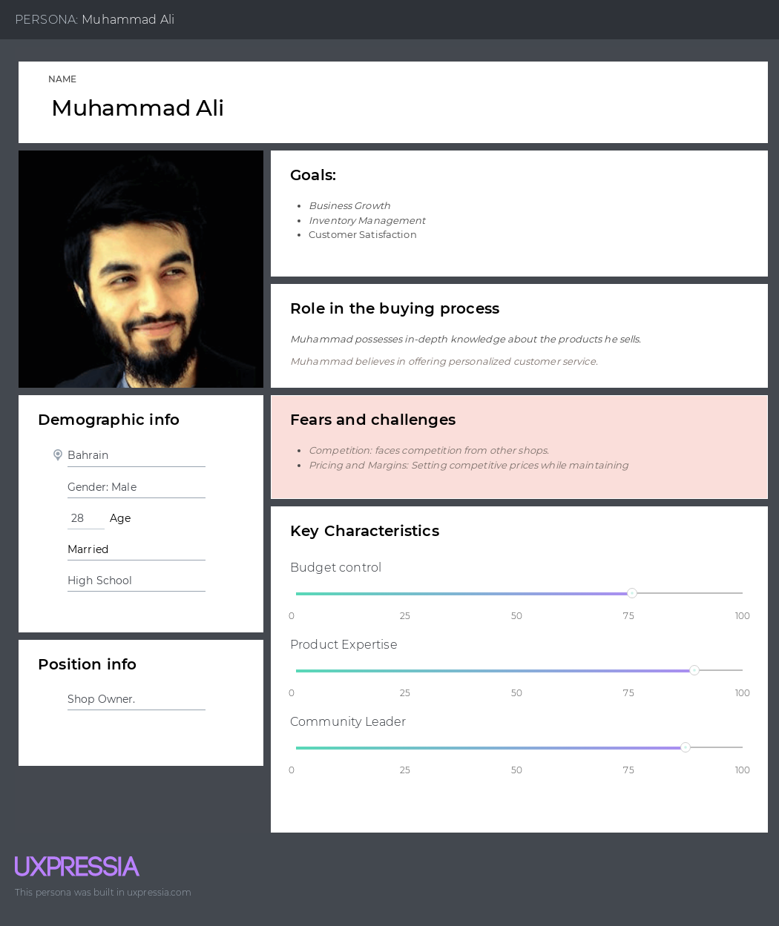

*Figure 4: User Persona*

**Scenario:**

Muhammad is the owner of an electronics shop. He has extensive experience in this field and with the products that he sells. Muhammad aims to increase his store’s revenues and expand his customer base by increasing his store’s sales. Muhammad always strives to satisfy his customers.

# **Moderator:**

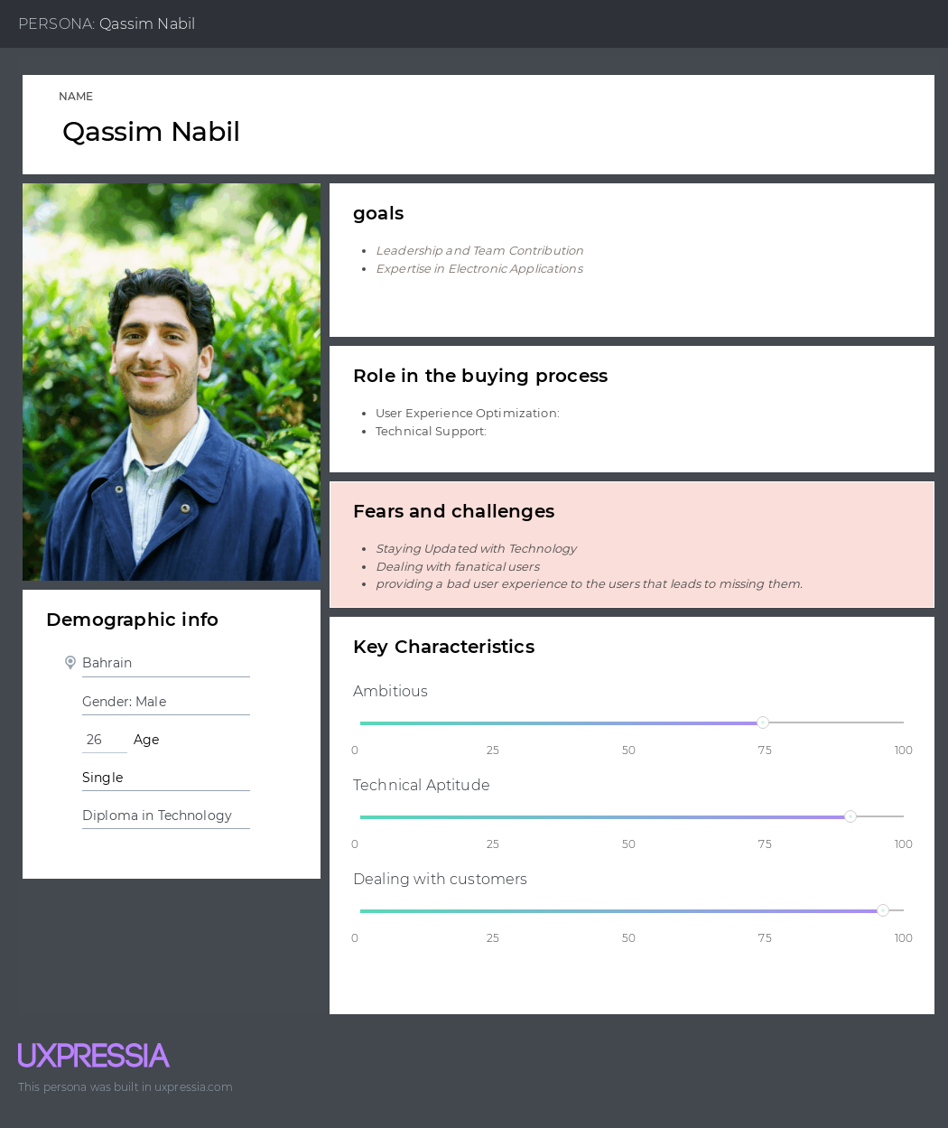

*Figure 4:* Moderator *Persona*

**Scenario:**

Qasim is an individual who developed a passion for technology from his early student days. He possessed a strong ambition to become a leader and a valuable contributor to a team. Qasim was dedicated to effectively managing his time and studies, always striving to acquire new skills and knowledge each day. After successfully completing his technology diploma, Qasim faced challenges in finding suitable job opportunities that matched what he wanted.

However, when an opportunity emerged to apply for a position as an electronic application manager for our website, Qasim eagerly seized the chance. He demonstrated his expertise and enthusiasm during the application process, which led to his acceptance for the role.

# **Admin:**

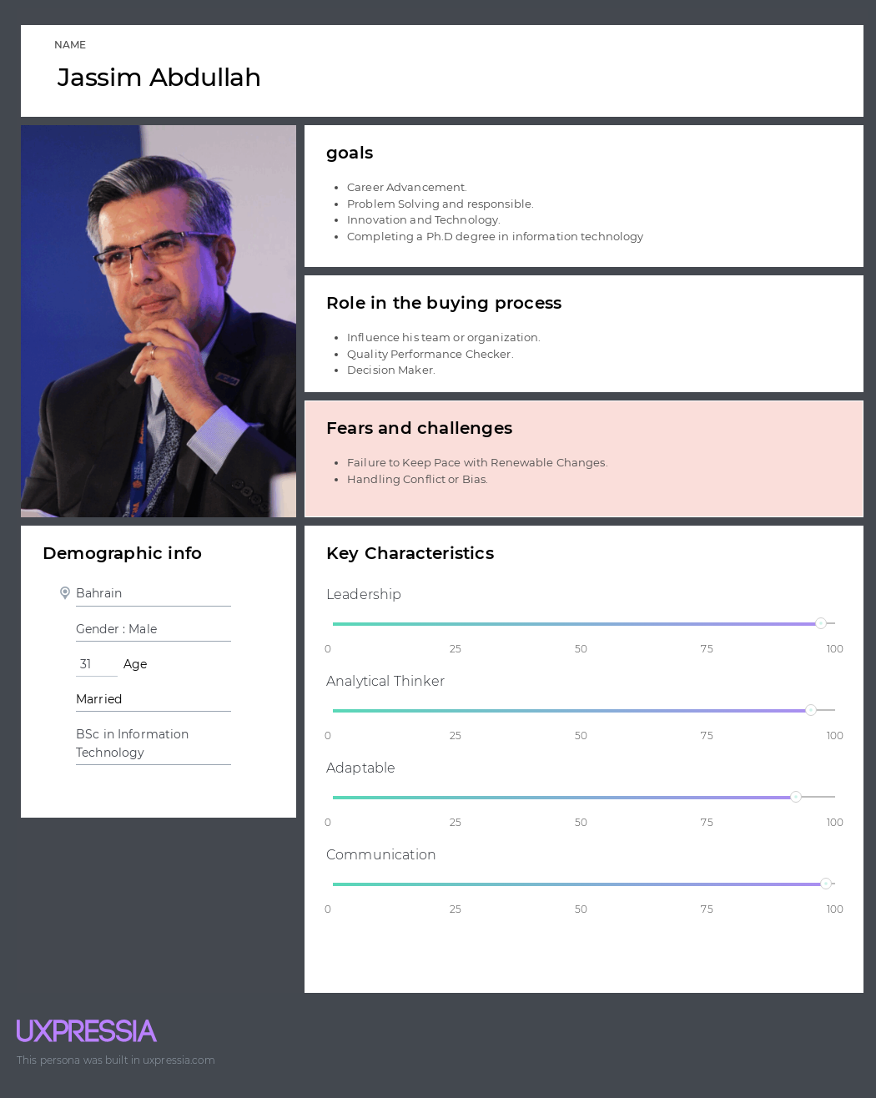

*Figure 4:* Admin *Persona*

**Scenario:**

Jassim Abdullah is a university graduate with a BSc in Information Technology. Jassim has a great passion for administrative and leadership matters and has gained extensive experience in the field of information technology and computing during his years of study at the university. He has strong communication skills with colleagues and clients and is characterized by the ability to take responsibility, solve complex problems, and make decisions. Jassim constantly strives to face challenges and explore new innovations.

## **System models**

-

dec

-

**4.4.1: Context level diagram:**

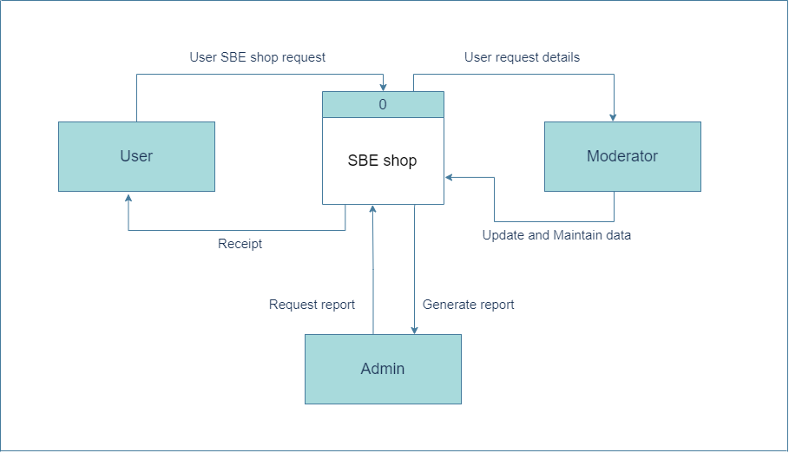

*Figure 4.12:* context-level diagram

The context-level diagram in Figure 4.12 presents the SBE Shop website. It shows the primary entities (Users, Moderators, and Administrators) and the key data flows connecting them to the system. Users, moderators, and administrators engage with their respective services, exchanging data as depicted in the diagram. This representation captures a high-level overview of interactions and data exchanges within the SBE Shop website system.

## **4.4.1.1: Level 0 (DFD)**

At this data flow diagram level, the system's processes are further detailed into the specific services offered by its data entities.

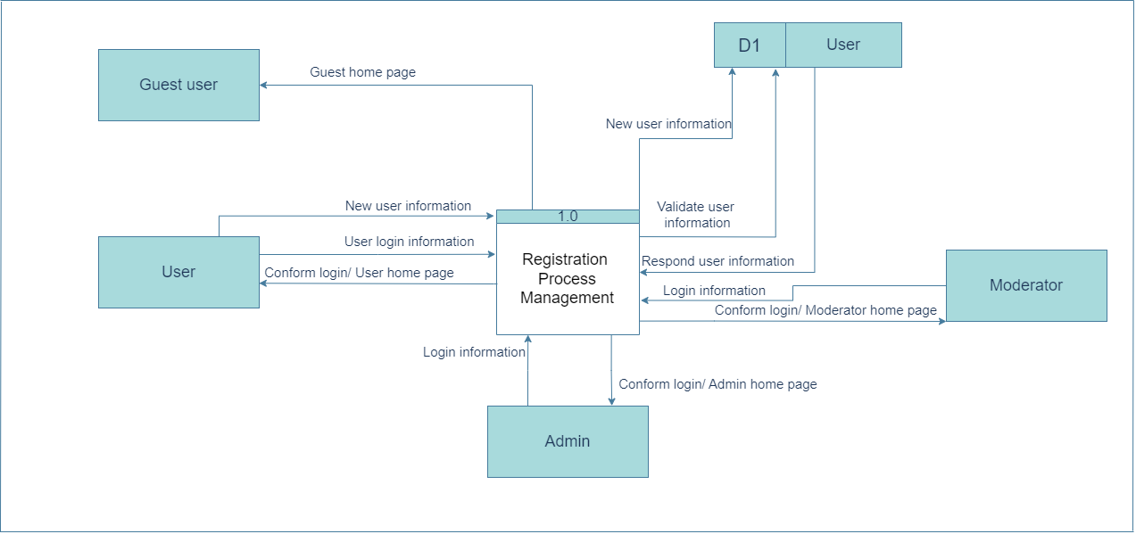

*Figure 4.13: Level 0, process 1.0*

Figure 4.13 above shows the registration management process on the SBE Shop website. involving four main entities, as shown in the figure above (Users, Guest Users, Moderators, and Administrators). This process allows all users to log in to the system and browse different pages. Except for guest users, it redirects them to the guest home page. As for users, they can register to the system by filling out the registration form and submitting it. After registering to the system, users can log in to the system. Additionally, the user can reset the password by entering the email address registered on the system and then verify it to complete the password change form by sending a message to the user's email address to reset the password. Password. (still not added in diagram)

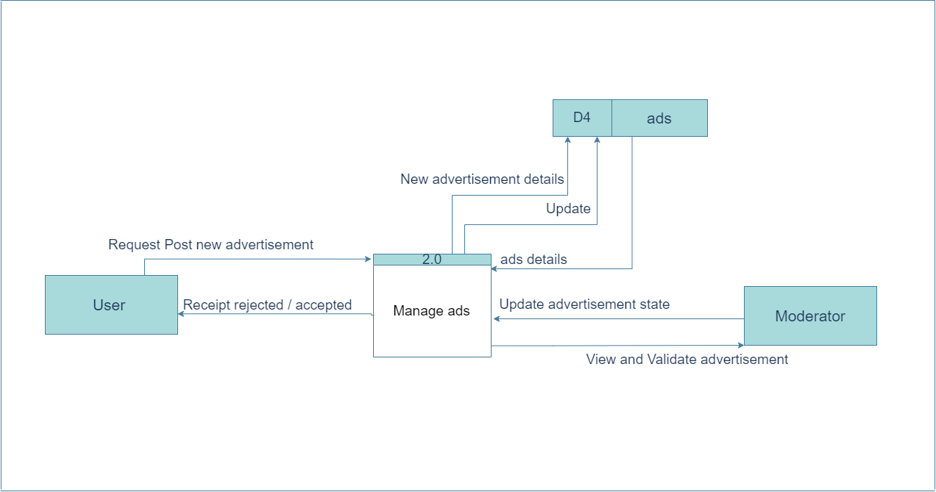

*Figure 4.14: Level 0, process 2.0*

Figure 4.14 above presents the manage ads process on the SBE Shop website.

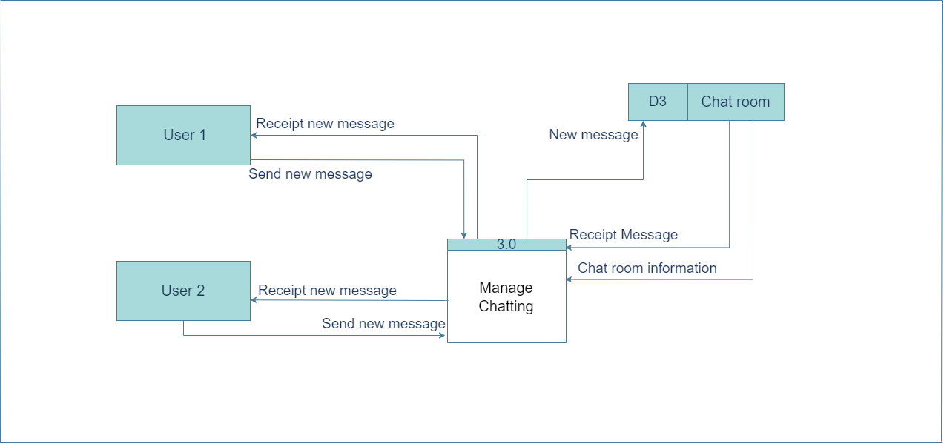 This process enables users to submit requests to add new advertisements. while also providing moderators with the ability to review and validate all sent requests. The moderators can then update the advertisement's status either by accepting or rejecting it. after which the users will receive the new status of their advertisement.

*Figure 4.15: Level 0, process 3.0*

Figure 4.15 above presents the managed chat process on the SBE Shop website.

This process enables users to chat with each other via text message in real time.

First, user 1 will send a new message, and it will be stored in the chat room shared between the two users. then user 2 will receive the message, and it will send a response message and vice versa.

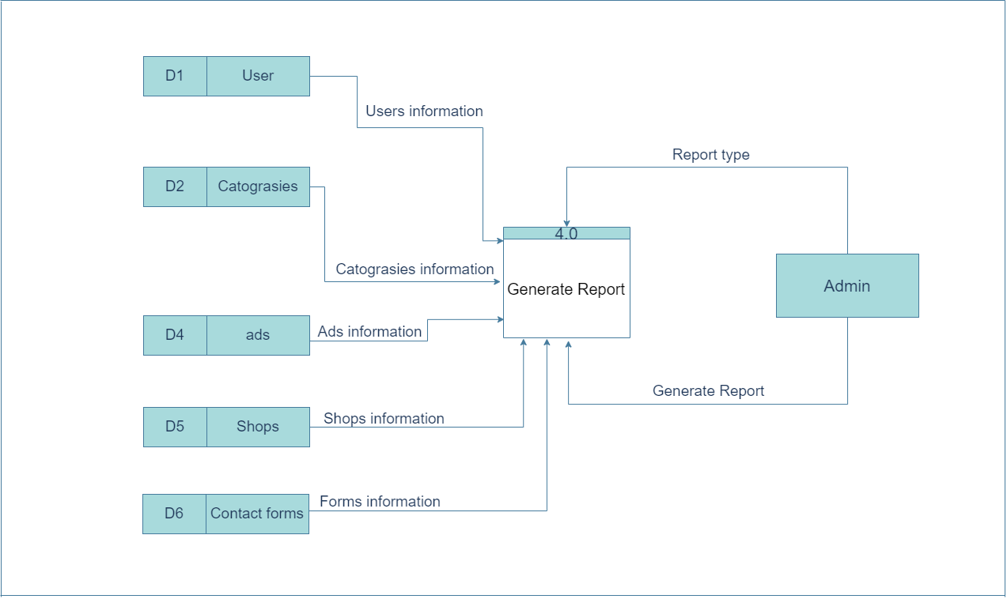

*Figure 4.16: Level 0, process 4.0*

Figure 4.16 above presents the generate reports process on the SBE Shop website. This process enables admin to generate reports by specifying the type of report. He or she can generate reports about users (main user and moderators), categories, advertisements, shops, and the contact us form.

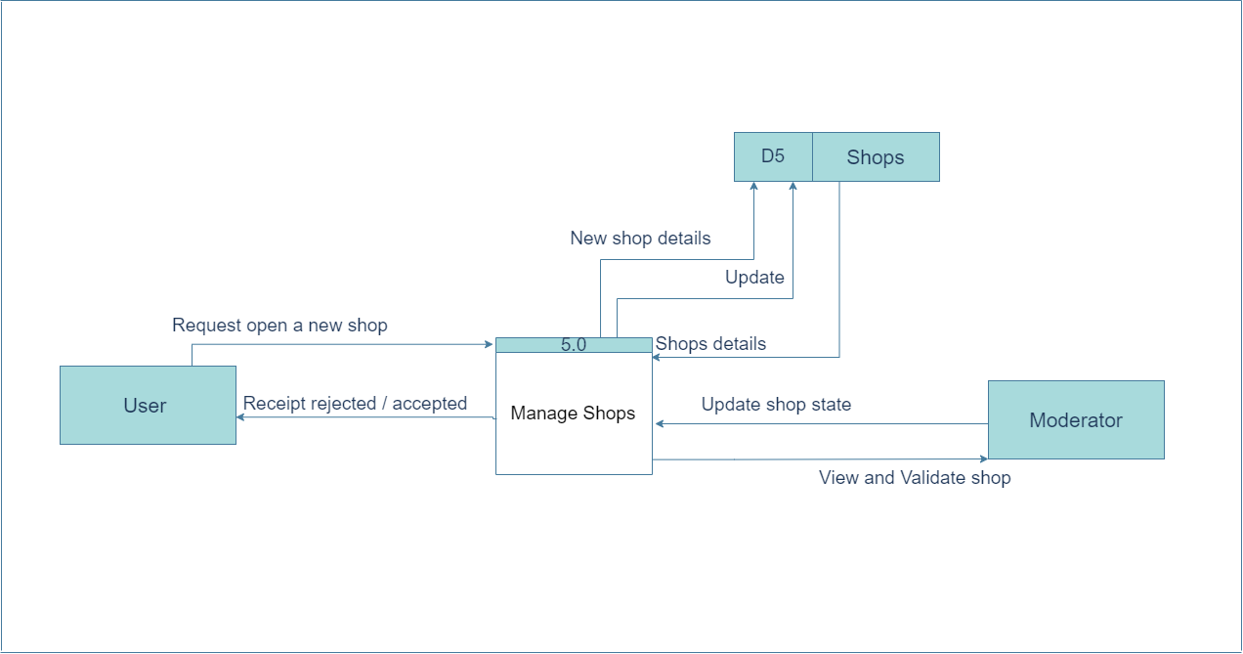

*Figure 4.17: Level 0, process 5.0*

Figure 4.17 above presents the manage shops process on the SBE Shop website. This process enables users to open a shop on the website. The system then validates if the user has all the requirements needed to open a shop. While also providing moderators with the ability to view and update the shop's status for all shops available.

Level 1:

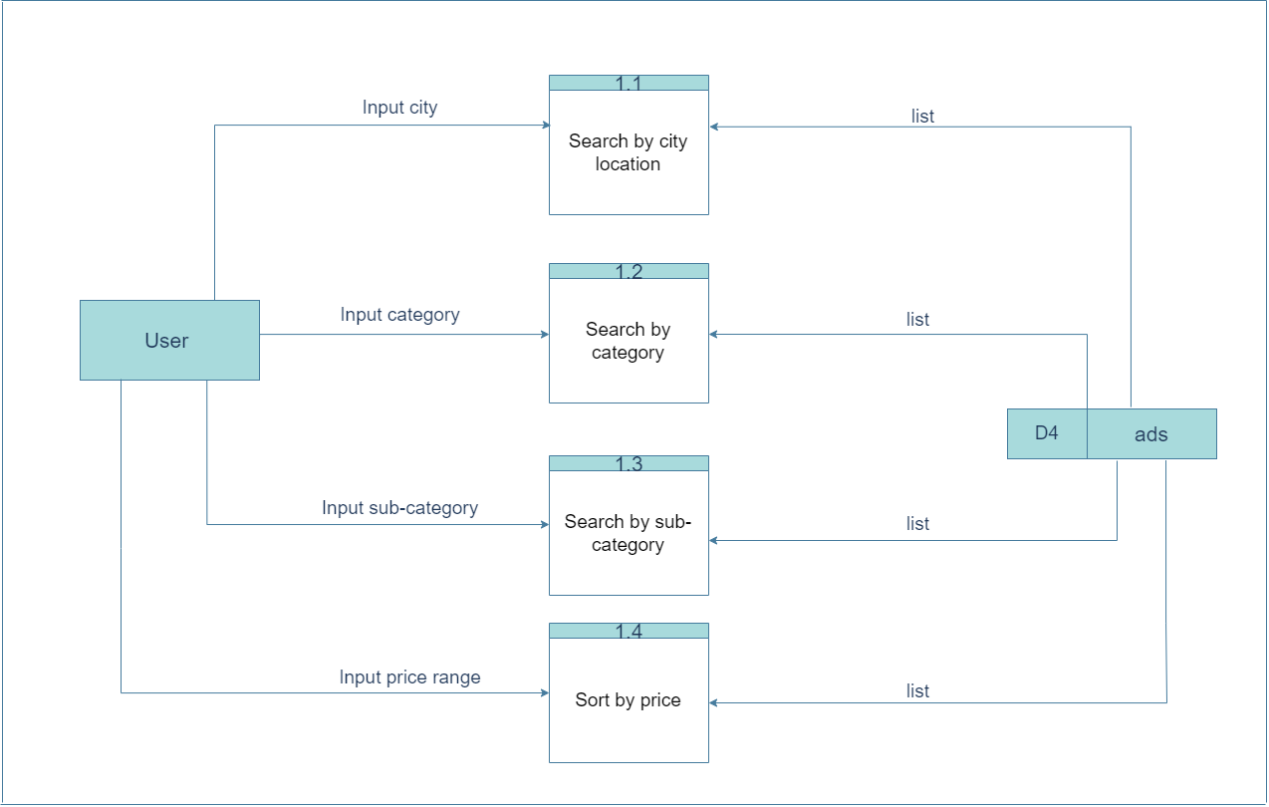 *Figure 4.18: Level 1, process .1.1- 4*

Figure 4.18 above presents the search process on the SBE Shop website.

This process empowers users to easily find advertisements by entering city name, category name, category name and sub-category name. Additionally, users have the option to further refine their search results by inputting a desired price range, specifying the minimum and maximum values. The system then provides the user with a comprehensive list of ads that match the searched data.

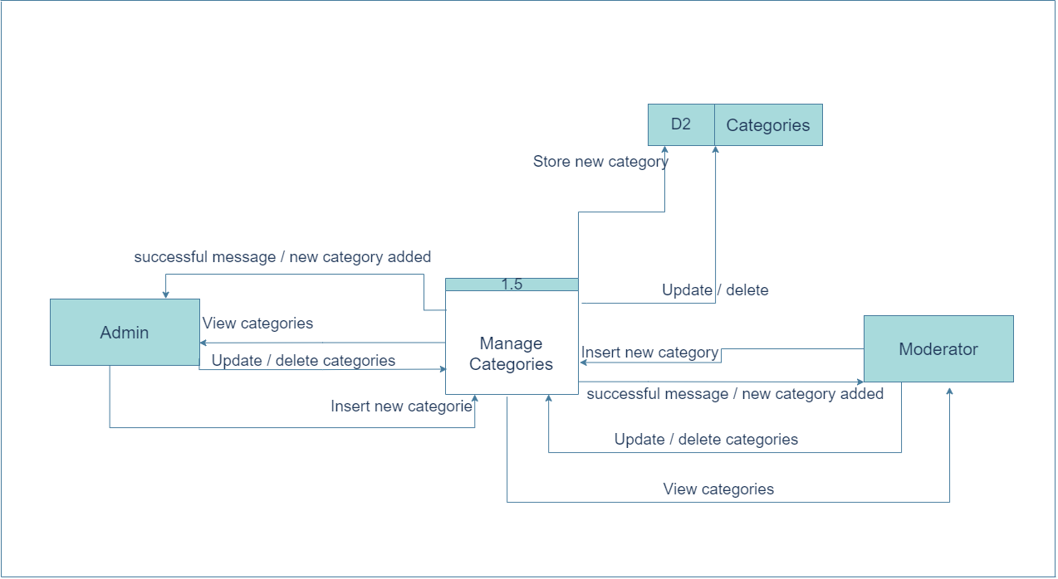 *Figure 4.19: Level 1, process 1.5*

Figure 4.19 above presents the manage categories process on the SBE Shop website.

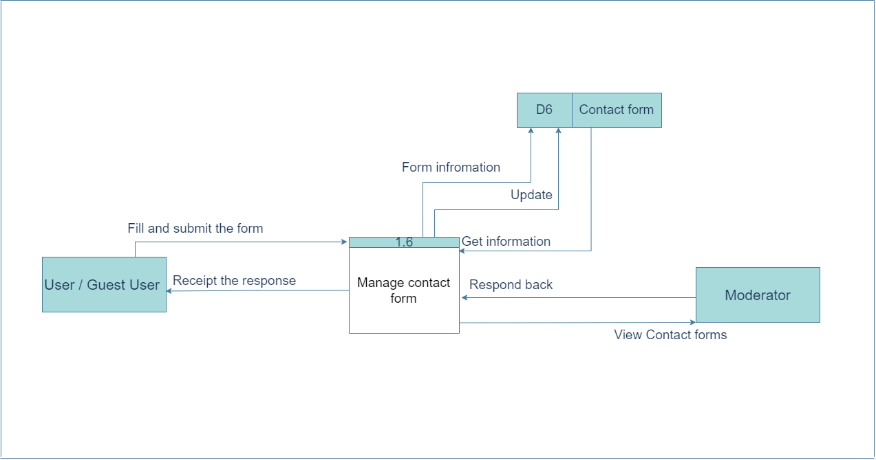This process allows admin and moderator to view,edit,detele and insert new category on the system.

*Figure 4.20: Level 1, process 1.6*

Figure 4.20 above presents the managed contact form process on the SBE Shop website.

The system seamlessly facilitates communication between users and shop owners by offering a convenient "Contact Us" form. This functionality enables users to submit their inquiries or feedback. Simultaneously, moderators are equipped with the capability to efficiently review and respond to all forms received. Once the moderators provide a reply, users will promptly receive the response, ensuring effective and timely communication. This form can be sent from users or gust users.

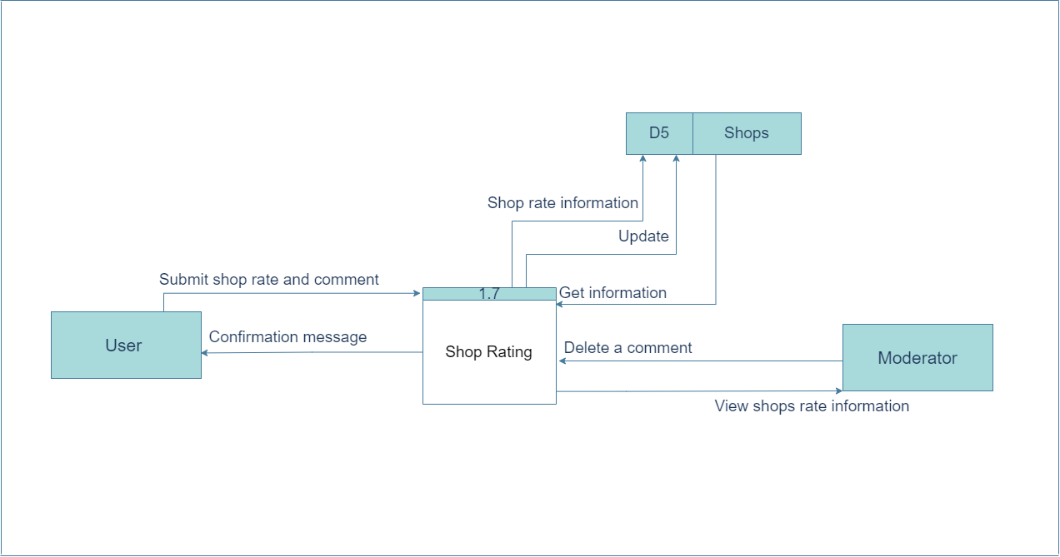

*Figure 4.21: Level 2, process 1.7*

Figure 4.21 above presents the managed contact form process on the SBE Shop website. The system allows the user to rate and comment on a shop. In addition, moderators can review the rating information associated with each shop and, if necessary, delete inappropriate or irrelevant comments.

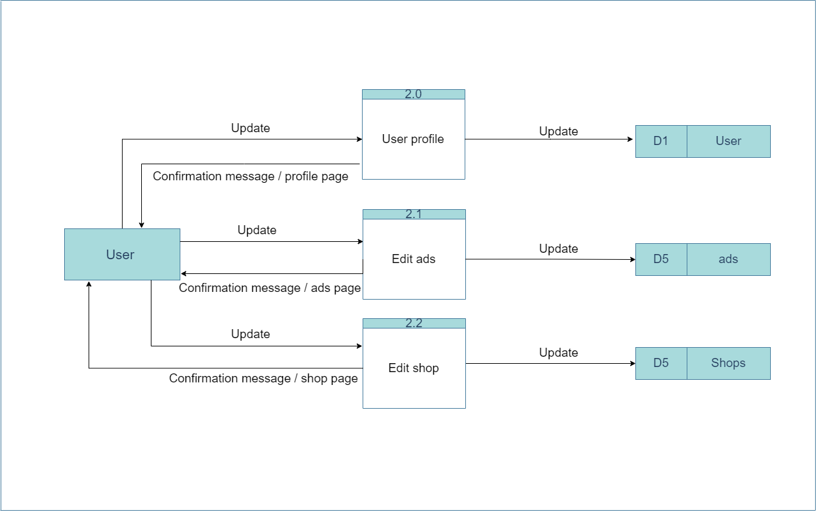Level 2:

*Figure 4.22: Level 2, process 2.0-2*

Figure 4.22 above presents the process of updating user profile, ads and shop details in SBE Shop website. The users will enter new data and it will be updated and the user will receive confirmation messages.

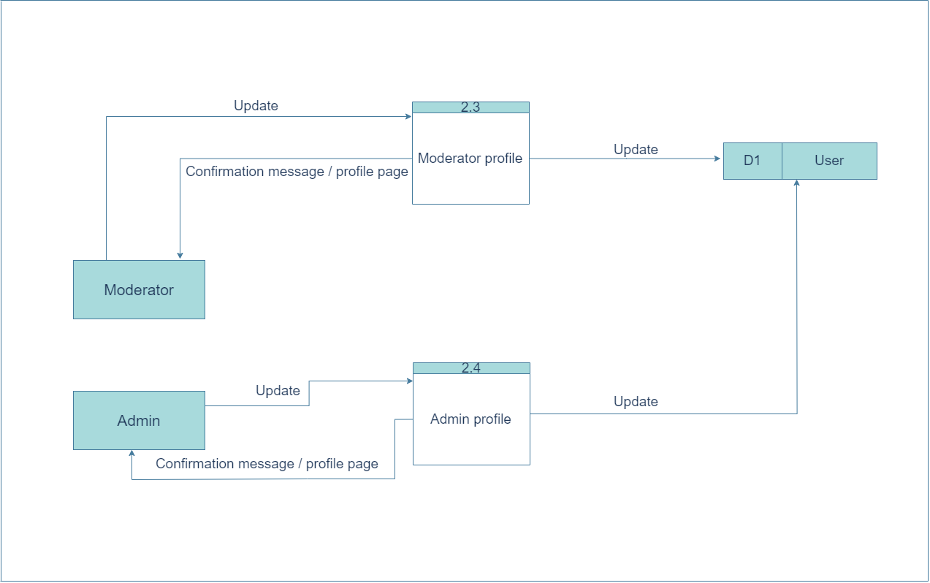

*Figure 4.23: Level 2, process 2.3-4*

Figure 4.23 above presents the process of updating moderator and admin profile in SBE Shop website.The moderator or admin will enter new data, and it will be updated, and the user will receive confirmation messages.

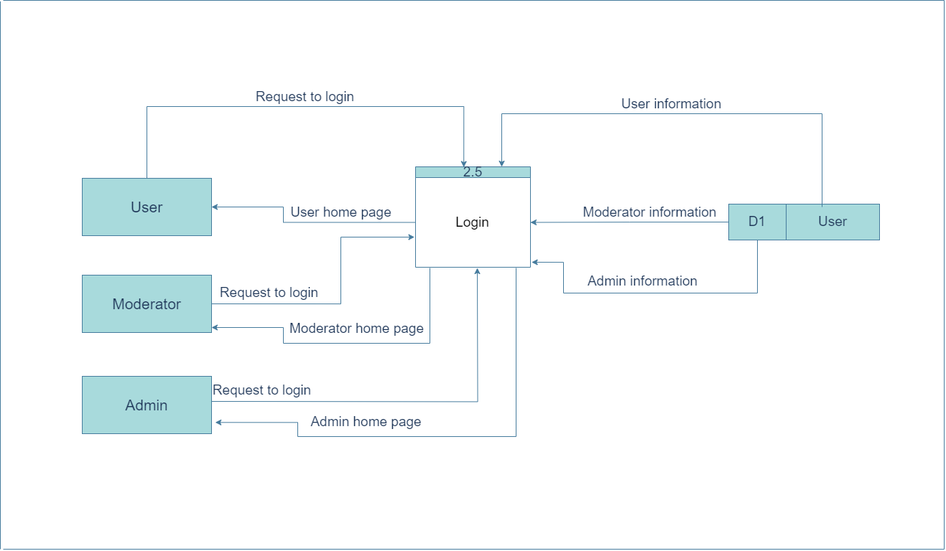

*Figure 4.24: Level 2, process 2.5*

Figure 4.24 above presents the process of login for users, moderator and admin in SBE Shop website. They will log in to the system and based on the type of user then the system will direct them to the related home page.

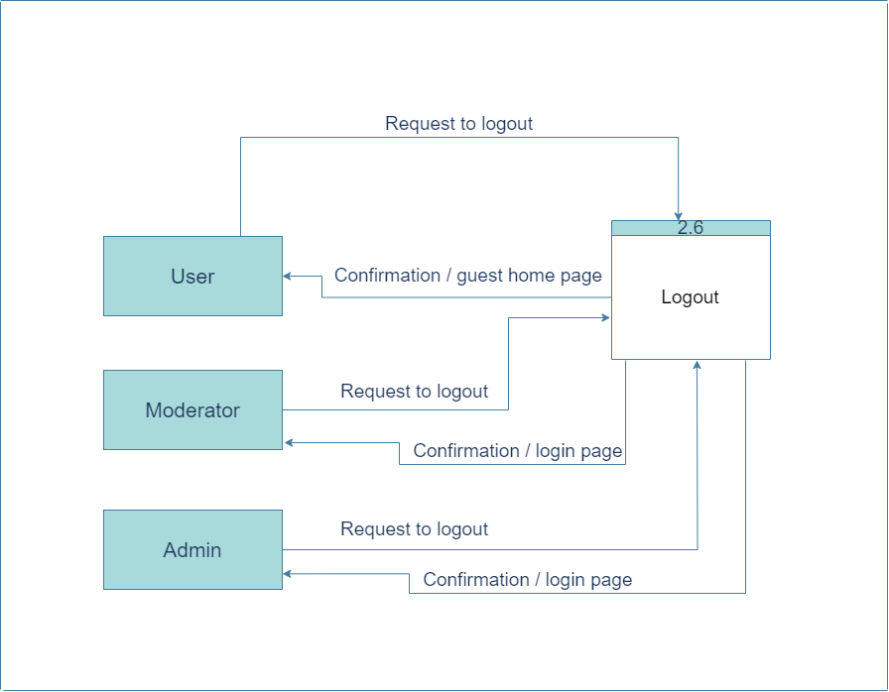

*Figure 4.25: Level 2, process 2.6*

Figure 4.22 above presents the process of logout for users, moderator and admin in SBE Shop website.